Consumption Reporting
This guide explains the cLMIS Consumption Reports.
In this guide, you will learn about:
- Consumption Report
- Reporting Monthly Data

About Consumption Reports
Monthly stock consumption is an important indicator that is calculated manually during the month. The District store operator enters data for the assigned Health Facilities to LMIS monthly consumption report.
Data can be entered for each month on or after the 1st date of the next month. Data entry operators can edit data for the last entered month for that store / facility.
To add the monthly stock consumption report:
- Sign in to the District User account.
User Home page displays.
- From the left menu, click Monthly Stock Consumption.
The Monthly Consumption page displays.
- The district store’s consumption report is displayed under District/Field Stores table. The list of health facilities is displayed under Health Facilities table.
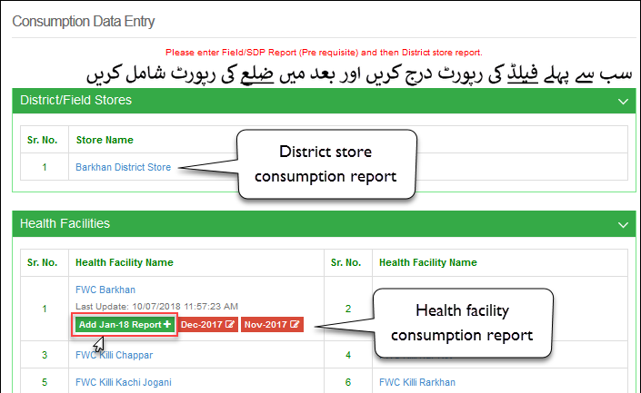
- Click Add Report under the required store.
The Consumption Reporting dialog opens.
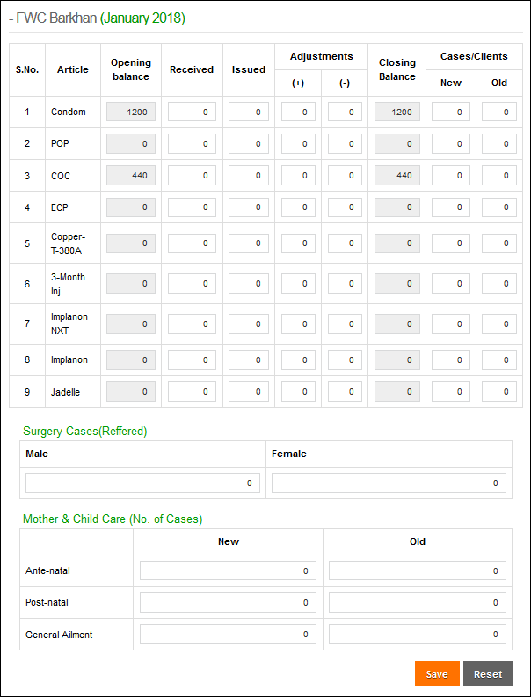
The user can specify the following for each product:
- Opening Balance: this balance is generated automatically based on previous months stock and consumption.
- Received: the user can enter the received amount for each product in this entry-box.
- Issued: the user can enter the issued amount for each product in this entry-box.
- Adjustments (+), (-): the user can enter the adjusted quantity for each product. If an additional quantity is added to stock that has not been issued (e.g., recovery), it should be added in the (+) adjustment entry-box. If some of the stock has become unusable due to theft, loss, expiry, etc., it should be added in the (-) adjustment entry-box.
- Closing Balance: the closing balance is calculated automatically.
- Cases/Clients: the user can enter the number of cases or clients entertained during the month in the health facility. The new cases are entered n the New entry box, whereas the old cases are entered in the Old entry box.
- In Surgery Cases (Referred), specify the Male and Female cases.
- In the Mother and Child Care (No. of Cases), the following options can be specified:
- Ante-natal: specify the New and Old ante-natal cases.
- Post-natal: specify the New and Old post-natal cases.
- General Ailment: specify the New and Old general ailment cases.
- Click Save to save the consumption report.
- The user can edit the last 2-months consumption report. Click the report to modify the data and then click Save.

LHW District User

Data Entry (Monthly Stock Consumption)
In order to add monthly stock consumption reports, click the Data Entry tab on the main menu.
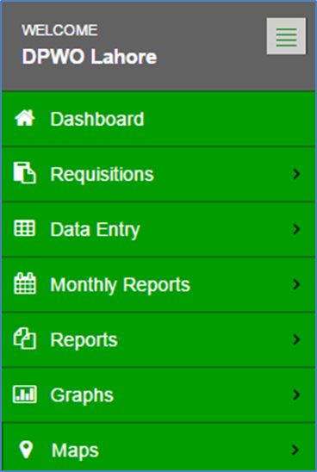
The data entry screen will be displayed.
The facility data entry screen will be displayed. To enter consumption data for a health facility, click the health facility name (DHQ Attock as shown in the screenshot
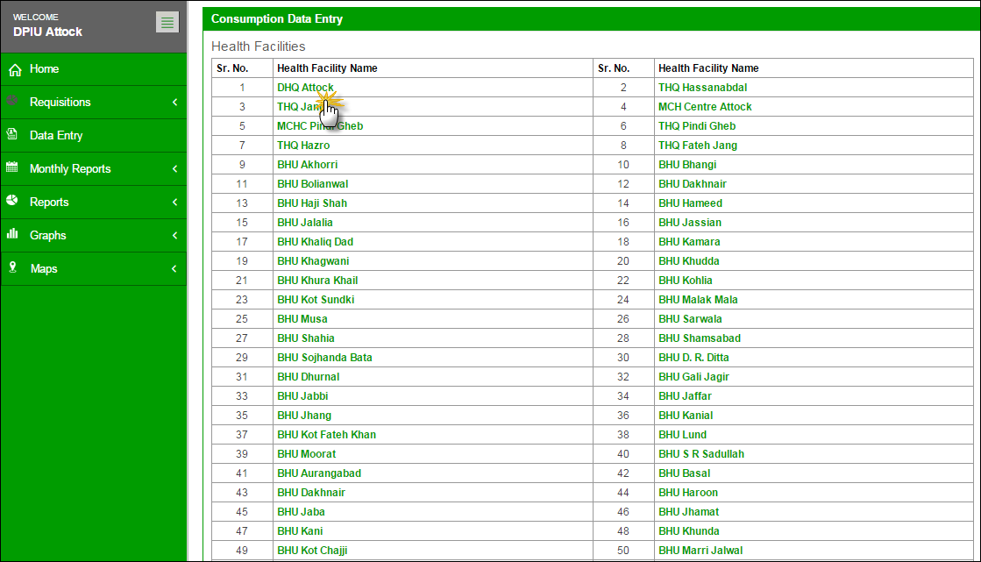
A number of consumption report options from previous and current months will display.
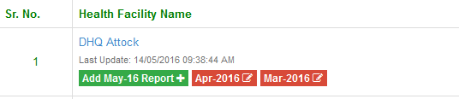
Click the Add [Month] Report. Once the user selects the Store/Facility and the month in which he/she wants to add data, a data entry screen will appear where the user can fill and save data for the reporting month.
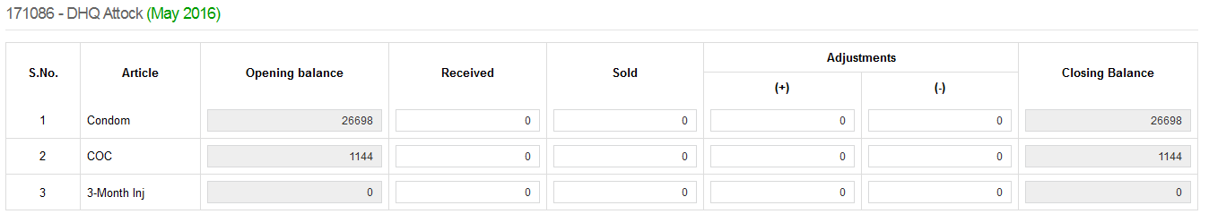
Enter the desired data within the form and click Save.
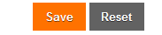
Users can also click Reset to either undo or make the changes.

PWD District User

Data Entry (Monthly Stock Consumption)
In order to add monthly stock consumption report, click Data Entry tab from the main menu.
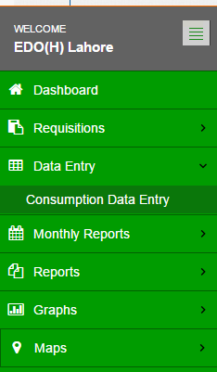

The facility data entry screen will be displayed. To enter consumption data for FHC/RHS-B, click the FHC or RHS-B name (FWC Lady Wellington Hospital as shown in the screenshot).
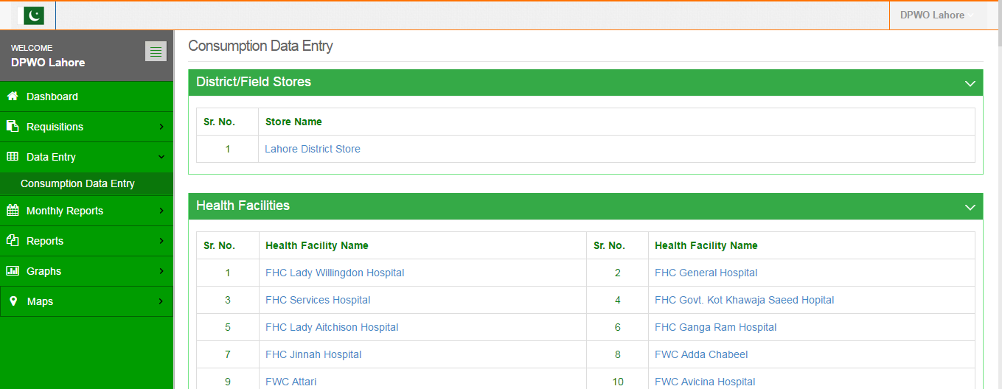
A number of consumption report options from previous and current months will display.
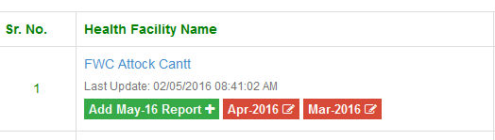
Click the Add [Month] Report. Once the user selects the Store/Facility and the month in which he/she wants to add data, a data entry screen will appear where the user can fill and save data for the reporting month.
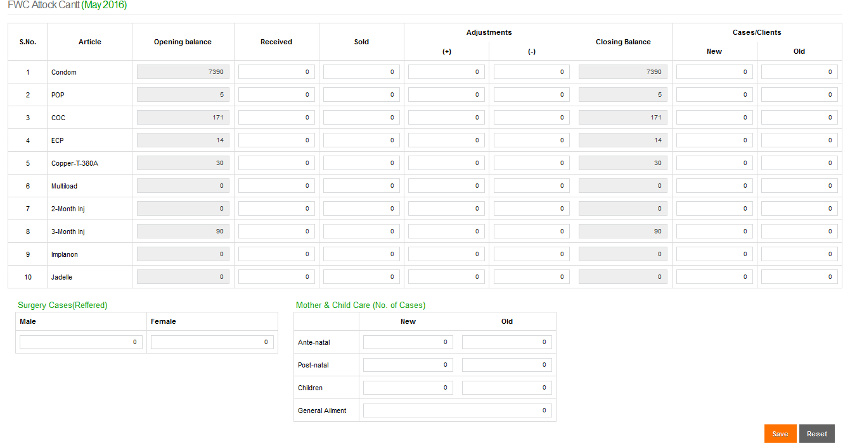
For PWD users, the data entry form shows additional fields which includes new and old cases or clients for each method.
Other fields include:
- Surgery cases (referred)
- Surgery cases (performed)
- Mother and Child Care (No. of cases)
  - Ante-natal (new and old)
  - Post-natal (new and old)
  - Children (new and old)
  - General Ailment
For FHC, RHS-A, and RHS-B of health facilities, the data entry form will contain surgery cases (performed) form for both males and females as shown below:
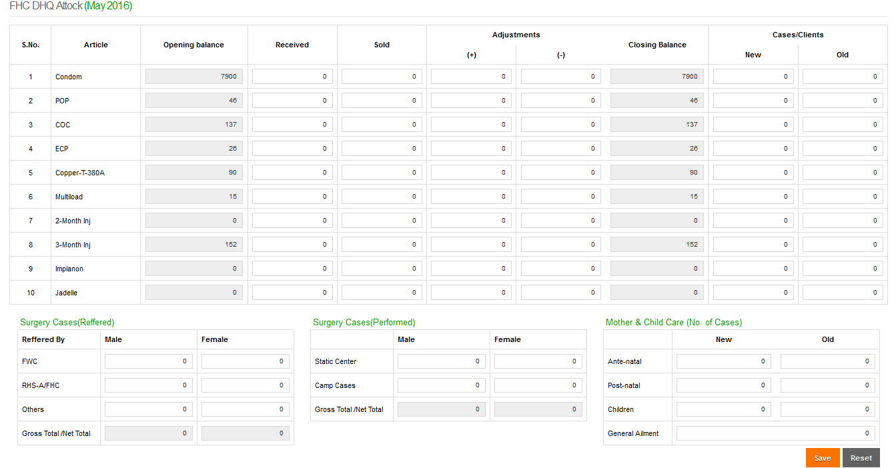
Enter the desired data within the form and click Save.
Users can also click Reset to either undo or make the changes.

